CN8861

Network Management

Assignment - 1

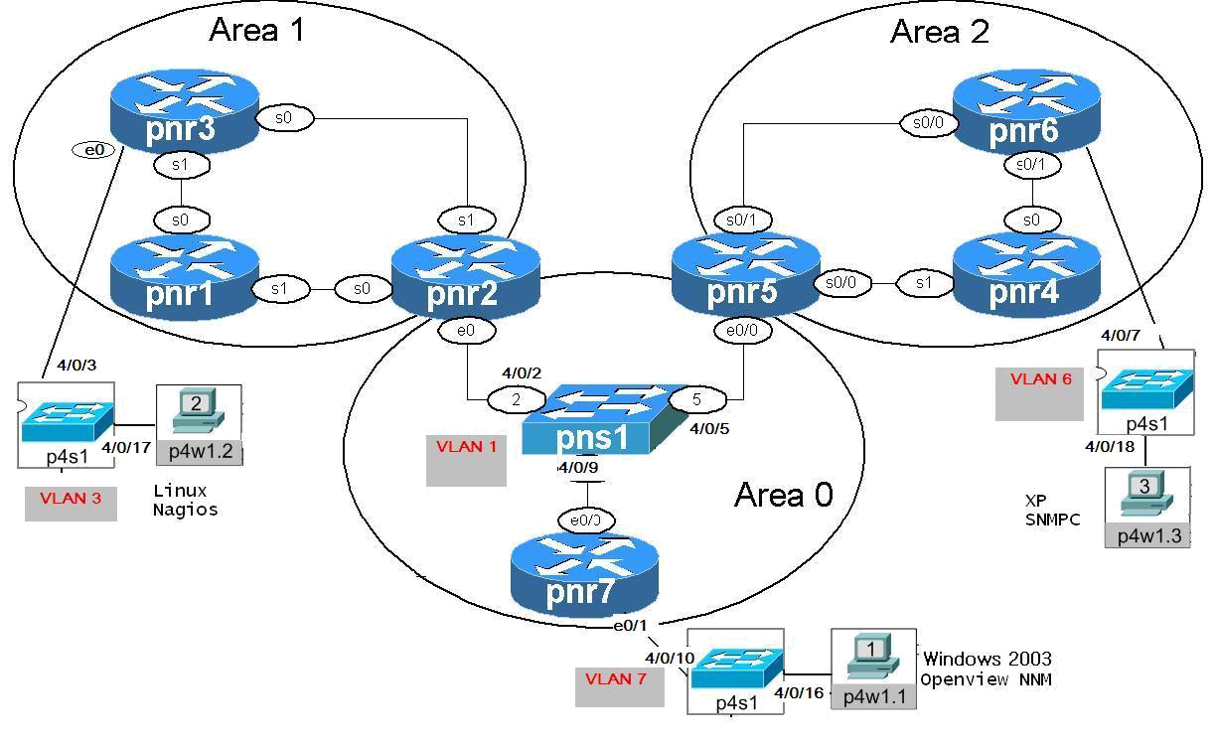

Figure 1 Logical Network Topology

NOTE: Use POD # 2, 3 and 6 to create Logical Network Topology as Figure-1. Create your own topology for POD# 24.

IP Address table
Device | Loopback0 | e0 |  | s0 | S1
R1 | 201.3(pod#).100.1/32 |  |  | 201.3(pod#).13.1/24 | 201.3(pod#).12.1/24
R2 | 201.3(pod#).100.2/32 | 201.3(pod#).128.2/24 |  | 201.3(pod#).12.2/24 | 201.3(pod#).23.2/24
R3 | 201.3(pod#).100.3/32 | 20.1.1.200/24 |  | 201.3(pod#).23.3/24 | 201.3(pod#).13.3/24
R4 | 201.3(pod#).100.4/32 |  |  | 201.3(pod#).46.4/24 | 201.3(pod#).45.4/24
Device | Loopback 0 | e0/0 | e0/1 | s0/0 | S0/1
R5 | 201.3(pod#).100.5/32 | 201.3(pod#).128.5/24 |  | 201.3(pod#).45.5/24 | 201.3(pod#).56.5/24
R6 | 201.3(pod#).100.6/32 | 10.1.1.100/24 |  | 201.3(pod#).56.6/24 | 201.3(pod#).46.6/24
R7  (FRS) | Loopback 0 | e0/0 | e0/1 | s0/0 | S0/1
R7  (FRS) | 201.3(pod#).100.7/32 | 201.3(pod#).128.7/24 | 40.1.1.100/24
R7  (FRS) | s0/2 | s0/3 | s1/0 | s1/1 | S1/2
R7  (FRS) | s1/3 | s1/4 | s1/5 | s1/6 | S1/7
Switch | Loopback 0 | VLAN100 | VLAN3 | VLAN6 | VLAN7
Switch | 201.3(pod#).100.8/32 | Port 2,5,9 | Port 3,17 | Port 7, 18 | Port 10,16
Device | Role | IP | Gateway | Platform | VMnet
(POD#)W1.1 | HP-NNMI | 40.1.1.20/24 | 40.1.1.100/24 | Windows 2003 | Vmnet0

- “Write erase” and “Reload” All device
- Copy and paste the following configuration to each device respectively.
- The basic SNMP agent is configured.

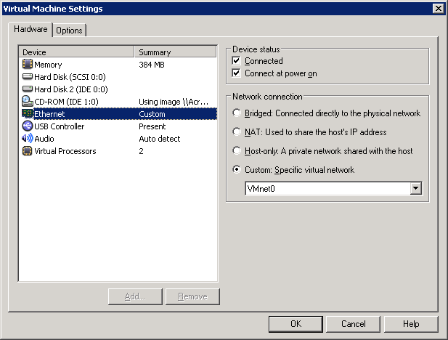
Fig. 2 Virtual Machine Setting

For HP-NNMI Server, choose VMnet0

For Nagios Server, choose VMnet1 (Optional)
For SNMPc Server, choose VMnet2 (Optional)

R7:
configure terminal
hostname R7
frame-relay switching
interface Serial1/1
no ip address
encapsulation frame-relay
clockrate 128000
frame-relay intf-type dce
frame-relay route 102 interface Serial1/2 201
no shutdown
exit
interface Serial1/2
no ip address
encapsulation frame-relay
clockrate 128000
frame-relay intf-type dce
frame-relay route 201 interface Serial1/1 102
no shutdown
exit
interface Serial1/0
no ip address
encapsulation frame-relay
clockrate 128000
frame-relay intf-type dce
frame-relay route 103 interface Serial1/5 301
no shutdown
exit
interface Serial1/5
no ip address
encapsulation frame-relay
clockrate 128000
frame-relay intf-type dce
frame-relay route 301 interface Serial1/0 103
no shutdown
exit
interface Serial1/3
no ip address
encapsulation frame-relay
clockrate 128000
frame-relay intf-type dce
frame-relay route 203 interface Serial1/4 302
no shutdown
exit
interface Serial1/4
no ip address
encapsulation frame-relay
clockrate 128000
frame-relay intf-type dce
frame-relay route 302 interface Serial1/3 203
no shutdown
exit
interface Serial1/7
no ip address
encapsulation frame-relay
clockrate 128000
frame-relay intf-type dce
frame-relay route 405 interface Serial0/0 504
no shutdown
exit
interface Serial0/0
no ip address
encapsulation frame-relay
clockrate 128000
frame-relay intf-type dce
frame-relay route 504 interface Serial1/7 405
no shutdown
exit
interface Serial1/6
no ip address
encapsulation frame-relay
clockrate 128000
frame-relay intf-type dce
frame-relay route 406 interface Serial0/3 604
no shutdown
exit
interface Serial0/3
no ip address
encapsulation frame-relay
clockrate 128000
frame-relay intf-type dce
frame-relay route 604 interface Serial1/6 406
no shutdown
exit
interface Serial0/1
no ip address
encapsulation frame-relay
clockrate 128000
frame-relay intf-type dce
frame-relay route 506 interface Serial0/2 605
no shutdown
exit
interface Serial0/2
no ip address
encapsulation frame-relay
clockrate 128000
frame-relay intf-type dce
frame-relay route 605 interface Serial0/1 506
no shutdown
exit

interface e0/0
ip address 201.3(pod#).128.7 255.255.255.0
no shutdown
exit

interface e0/1
ip address 40.1.1.100 255.255.255.0
no shut
exit

interface Loopback 0
ip address 201.3(pod#).100.7 255.255.255.255

interface loopback 1
ip address 201.3(pod#).100.17 255.255.255.255
# loopback 1, used for linkup/linkdown test

Router ospf 1
Network 201.3(pod#).128.0 0.0.0.255 area 0
Network 201.3(pod#).100.0 0.0.0.255 area 0
Network 40.1.1.0 0.0.0.255 area 0

Switch:

configure terminal
interface FastEthernet4/0/2
switchport mode access
switchport access vlan 100
exit

interface FastEthernet4/0/5
switchport mode access
switchport access vlan 100
exit

interface FastEthernet4/0/9
switchport mode access
switchport access vlan 100
exit

interface FastEthernet4/0/16
switchport mode access
switchport access vlan 7
exit

interface FastEthernet4/0/10
switchport mode access
switchport access vlan 7
exit

interface FastEthernet4/0/3
switchport mode access
switchport access vlan 3
exit

interface FastEthernet4/0/17
switchport mode access
switchport access vlan 3
exit

interface FastEthernet4/0/18
switchport mode access
switchport access vlan 6
exit

interface FastEthernet4/0/7
switchport mode access
switchport access vlan 6
exit

ip default-gateway 201.3(pod#).128.7
int vlan 100
ip address 201.3(pod#).128.8 255.255.255.0
no sh

End

R1

configure terminal
hostname R1

interface Loopback 0
ip address 201.3(pod#).100.1 255.255.255.255

interface s0
encapsulation frame-relay
ip address 201.3(pod#).13.1 255.255.255.0
ip ospf network point-to-point
no shutdown

interface s1
encapsulation frame-relay
ip address 201.3(pod#).12.1 255.255.255.0
ip ospf network point-to-point
no shutdown

router ospf 1
network 201.3(pod#).13.0 0.0.0.255 area 1
network 201.3(pod#).12.0 0.0.0.255 area 1
network 201.3(pod#).100.0 0.0.0.255 area 1
end

R2:

configure terminal
hostname R2

interface Loopback 0
ip address 201.3(pod#).100.2 255.255.255.255

interface s0
encapsulation frame-relay
bandwidth 1544
ip address 201.3(pod#).12.2 255.255.255.0
ip ospf network point-to-point
no shutdown

interface s1
encapsulation frame-relay
no ip address
bandwidth 1544
ip address 201.3(pod#).23.2 255.255.255.0
ip ospf network point-to-point
no shutdown

interface e0
ip address 201.3(pod#).128.2 255.255.255.0
no shutdown

router ospf 1
network 201.3(pod#).12.0 0.0.0.255 area 1
network 201.3(pod#).23.0 0.0.0.255 area 1
network 201.3(pod#).100.0 0.0.0.255 area 1
network 201.3(pod#).128.0 0.0.0.255 area 0
end

R3:

configure terminal
hostname R3

interface Loopback 0
ip address 201.3(pod#).100.3 255.255.255.255

interface s0
encapsulation frame-relay
bandwidth 1544
ip address 201.3(pod#).23.3 255.255.255.0
ip ospf network point-to-point
no shutdown

interface s1
encapsulation frame-relay
bandwidth 1544
ip address 201.3(pod#).13.3 255.255.255.0
ip ospf network point-to-point
no shutdown

interface e0
ip address 20.1.1.200 255.255.255.0
no shutdown

router ospf 1
network 201.3(pod#).0.0 0.0.255.255 area 1
network 20.1.1.0 0.0.0.255 area 1
end

R4:
configure terminal
hostname R4

interface Loopback 0
ip address 201.3(pod#).100.4 255.255.255.255

interface s0
encapsulation frame-relay
ip address 201.3(pod#).46.4 255.255.255.0
ip ospf network point-to-point
bandwidth 1544
no shutdown

interface s1
encapsulation frame-relay
ip address 201.3(pod#).45.4 255.255.255.0
ip ospf network point-to-point
bandwidth 1544
no shutdown

router ospf 10
network 201.3(pod#).0.0 0.0.255.255 area 2
end

R5:

configure terminal
hostname R5

interface Loopback 0
ip address 201.3(pod#).100.5 255.255.255.255

interface s0/0
encapsulation frame-relay
ip address 201.3(pod#).45.5 255.255.255.0
ip ospf network point-to-point
bandwidth 1544
no shutdown

interface s0/1
encapsulation frame-relay
ip address 201.3(pod#).56.5 255.255.255.0
ip ospf network point-to-point
bandwidth 1544
no shutdown

interface e0/0
ip address 201.3(pod#).128.5 255.255.255.0
no shutdown

router ospf 10
network 201.3(pod#).45.0 0.0.0.255 area 2
network 201.3(pod#).56.0 0.0.0.255 area 2
network 201.3(pod#).100.5 255.255.255.255 area 2
network 201.3(pod#).128.0 0.0.0.255 area 0
end

R6:

configure terminal
hostname R6

interface Loopback 0
ip address 201.3(pod#).100.6 255.255.255.255

interface s0/0
encapsulation frame-relay
ip address 201.3(pod#).56.6 255.255.255.0
ip ospf network point-to-point
bandwidth 1544
no shutdown

interface s0/1
ip address 201.3(pod#).46.6 255.255.255.0
bandwidth 1544
encapsulation frame-relay
ip ospf network point-to-point
no shutdown

interface e0/0
ip address 10.1.1.100 255.255.255.0
no shutdown

router ospf 10
network 201.3(pod#).0.0 0.0.255.255 area 2
network 10.1.1.0 0.0.0.255 area 2
end

SNMP Configuration for ALL Devices

conf t
no ip domain-lookup
line con 0
logging synchronous
end

conf t
snmp-server community public RO
snmp-server community private RW
snmp-server trap-source Loopback0
snmp-server location (POD#) lab room , Building EPH , Ryerson
snmp-server contact 8861 Admin, 647-888-6666
snmp-server enable traps snmp authentication linkdown linkup coldstart warmstart
snmp-server host 40.1.1.20 traps public
end

